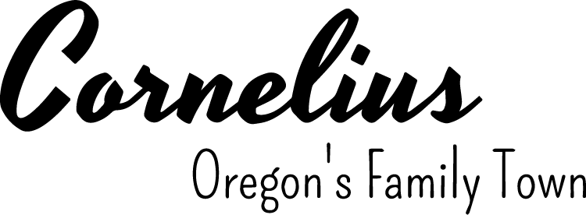
NOTICE OF PUBLIC HEARING on Zone Change (ZC-01-23)

The Public Hearings previous scheduled before the Planning Commission on July 25, 2023 and City Council on August 7, are now scheduled before the Cornelius Planning Commission on August 22, 2023 and the Cornelius City Council on September 5, 2023. The purpose of the hearings is to allow for input from interested parties, affected agencies and the general public on the proposed amendment. The amendment will be presented to the Planning Commission for approval and a formal recommendation forwarded to the City Council. The amendment is as follows:

ZC-01-23, Change of Zone from Washington County AF-5 Zone to City R-10 Zone

Cornelius Municipal Code Chapter 18.125 regulates Amendments to the Zoning Ordinance. Applicable approval criteria are found in 18.125.010 (C).

Planning Commission and City Council meetings begin at 7:00 p.m. in the City of Cornelius Council Chambers, 1355 N. Barlow Street, Cornelius, Oregon. You may also participate electronically or by phone following instructions as follows: PLANNING COMMISSION ZOOM MEETING (ONLINE)* https://zoom.us/j/88657023542 ;United States:1 - (253) 215-8782 Meeting ID 886 5702 3542, CITY COUNCIL ZOOM MEETING (ONLINE)* https://zoom.us/j/4174814374 ;United States:1 - (253) 215-8782 Meeting ID 417 481 4374

A copy of the application, all documents and evidence relied upon by the applicant, the staff report (published seven days prior to the hearing), and applicable criteria are available for inspection at no cost and may be purchased at the Cornelius Community Development Department at 1300 S. Kodiak Circle, Cornelius at cost; viewed on the web (www.ci.cornelius.or.us); or call Barbara Fryer, Community Development Director at 503-357-3011 for additional information.

At the times and place listed above, all persons will be given a reasonable opportunity to give testimony either for or against the proposal. Testimony may be either oral or written and must be relevant to the criteria listed above on which the proposal will be evaluated. Failure to raise an issue with sufficient specificity to afford the Commission or Council and the parties an opportunity to respond to the issue, precludes an appeal based on that issue.

At the public hearing, the Chair will open the public hearing, a staff report will be presented, and interested persons will be allowed to speak for or against the proposal and to ask questions. Planning Commission members and City Council members may ask questions prior to the conclusion of each public hearing. Once the public hearing is closed there will be no further testimony from the public. The Planning Commission and the City Council respectively, may approve a final decision recommending or adopting the proposed amendments, continue the public hearing, or direct staff to make final changes and return for adoption of the final written decision at a public meeting. Final approved amendments shall be adopted by a City ordinance.

THE CITY OF CORNELIUS Mailed on July 26, 2023


Barbara Fryer, AICP
Community Development Department Director
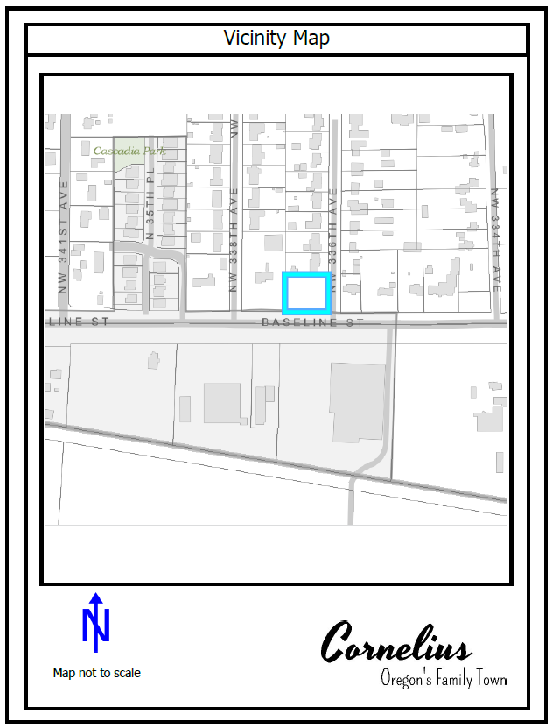

Site,
0 336th Avenue

